|  |
| --- |
| JAMES WHITE |
| ONLINE SLOT MACHINE |
| **[COMP 2068 – Assignment 2]** |
| Version #1.0  All work Copyright © 2014 by James White.  All rights reserved. |
| **James White** |
|  |

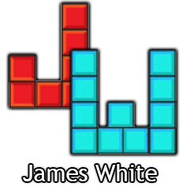

|  |
| --- |
| October 12th, 2014 |

**Table of Contents**

[Your Table of Contents should go here. Make sure that your document’s sections are hyperlinked to their corresponding pages.]

**Version History**

[This is where you keep track of the detailed changes made to your document throughout the course of development.]

[This is the body of your video game design document. You should add and delete sections as they pertain to your game’s design.]

1. **Game Overview**

*This is a slot machine, you play until you run out of money, or cash out!*

1. **Game Play Mechanics**

*You choose how much you want to bet and then spin the slots to see if you win!*

1. **Camera**

*Straight on*

1. **Controls**

*Mouse movement + Mouse Click 1*

1. **Saving and Loading**

*No saving/loading, just resetting the game.*

1. **Interface Sketch**

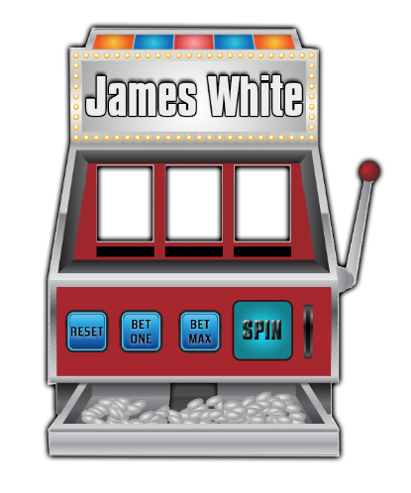

1. **Menu and Screen Descriptions**

*Just the slot machine*

1. **Scoring**

Getting a winning combo on the slots

1. **Bonuses**

Triple 7s for the jackpot

1. **Sound Index**

*(Include an index of all your sound clips)*

1. **Art / Multimedia Index**

*(Include an index of all your graphic and video assets here)*

1. **Design Notes**

*(Include additional design notes here)*